41 children receive a cancer diagnosis every day.

The National Cancer Institute designates 5.6 billion dollars for cancer research annually. Sadly, only .5% to 3% of these funds are allocated toward children’s cancer research.

Your help will allow us, the Childhood Gynecologic Cancer Association (CGYNCA), to continue helping patients, families, and medical professionals fight gynecologic cancer. This type of cancer can impact any girl. The most common form of childhood gynecologic cancer is ovarian cancer. Yes! Ovarian cancer can occur in young girls.

Giving for tomorrow shapes tomorrow.
CGYNCA is an educational non-profit organization founded to improve information sharing about childhood gynecologic cancers for families and medical professionals and to support research on childhood gynecologic cancers.

Whether you are in Ann Arbor, New York City, Dallas, San Francisco or another United States City, the need remains. Children with cancer must receive proper investment.

Our 5 Goals

The Childhood Gynecologic Cancer Association is dedicated to achieving 5 goals
- Developing a comprehensive referral resource center for children and adolescents with ovarian cancer, vulvar cancer, vaginal cancer or cervical cancer.
- Obtaining current information for education and clinical trials.
- Providing a forum on childhood gynecologic cancers for providers, patients, and their families.
- Raising money for an international tumor registry (database).
- Raising money to advance research on the causes, treatments, and cures for childhood gynecologic cancers.
These cancers are rare, but not to the children and families going through gynecologic cancer. Until recently, minimal resources were available for families and health care providers.

With your gift, we can achieve our 5 goals!

This is the moment to give your generous donation to the Childhood Gynecologic Cancer Association (CGYNCA). Please send your tax deductible gift no later than October 15, 2016.

You may make your donation online at http://www.cgynca.org/
(Ctrl+Click to follow link)

OR

Send your check payable to:

The Childhood Gynecologic Cancer Association (CGYNCA)
Post Office Box 3130
Ann Arbor, Michigan 48106-3130

OR

Use your cell phone to scan the QR code below

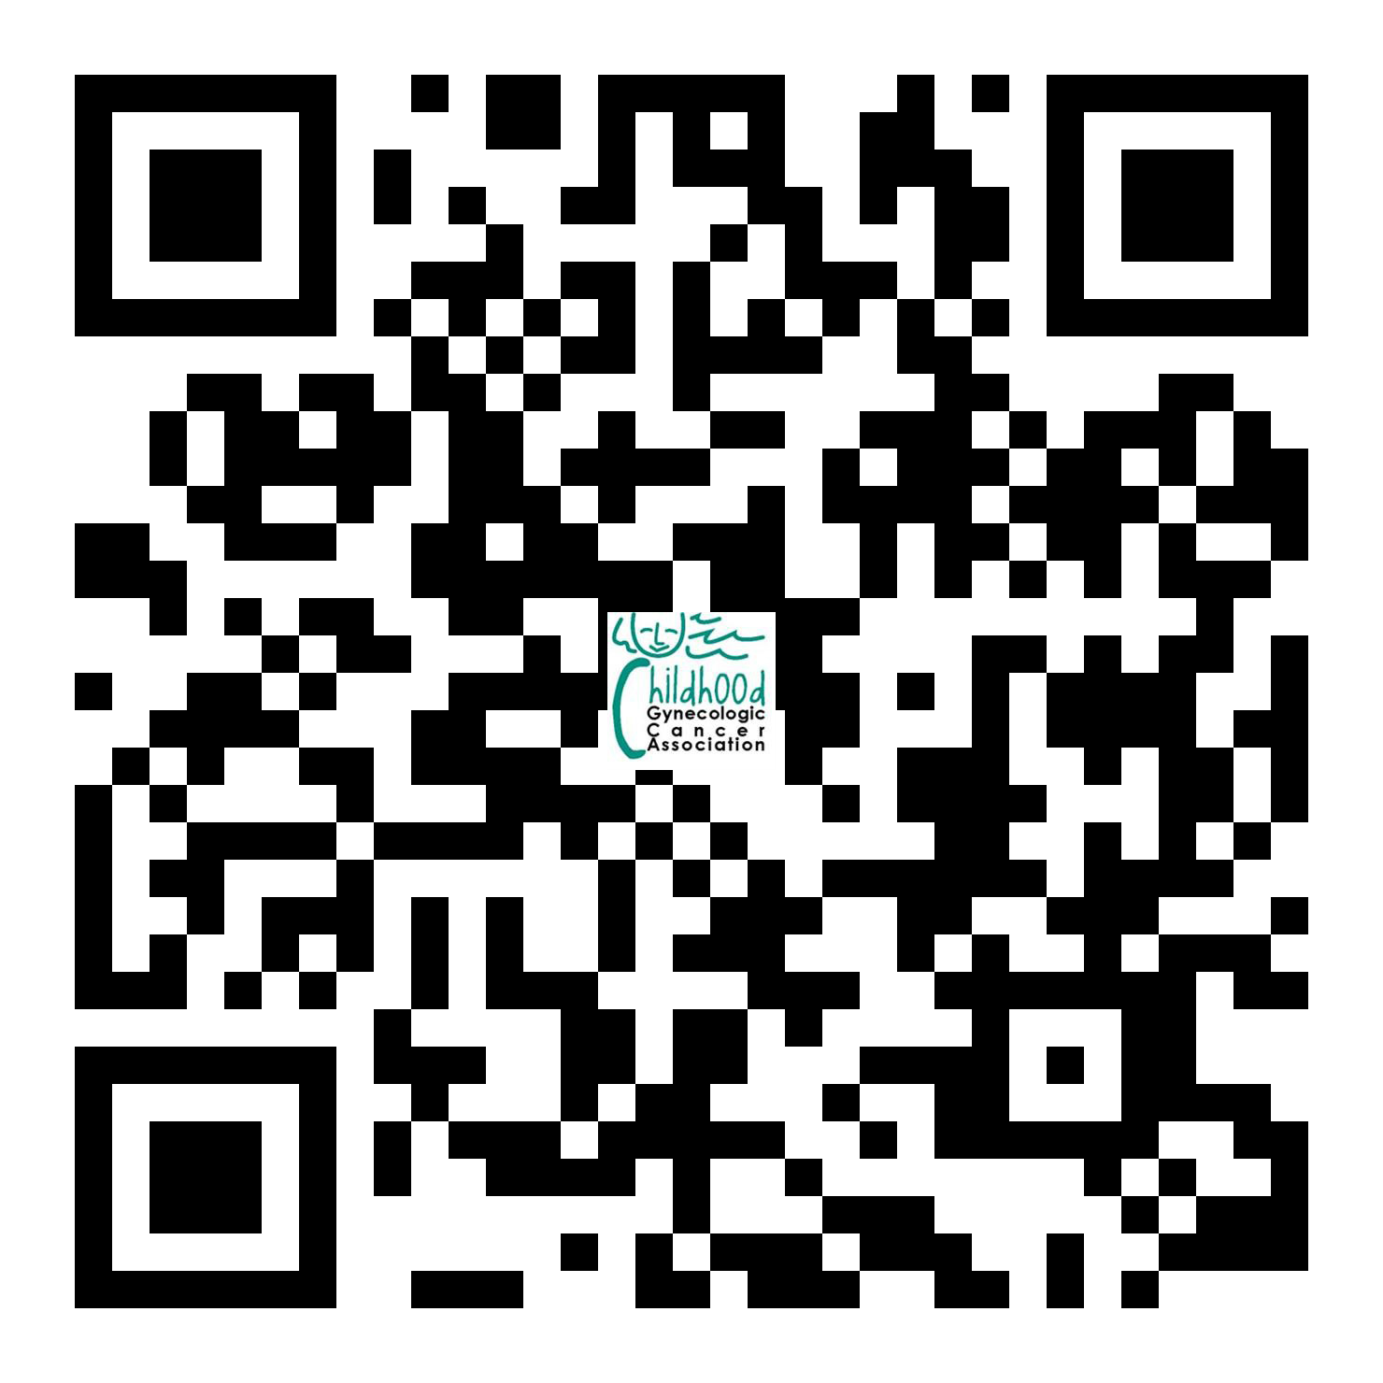

Kindest Regards,

Barbara Getty, NP

Hope Haefner, MD
Childhood Gynecologic Cancer Association (CGYNCA)
Executive Director

P.S. September is Childhood Cancer Awareness Month. Each September we will celebrate the investment you make today!

(Please Return This Page With Your Donation. PLEASE PRINT YOUR INFORMATION.)

Name:  Mailing address: | Donation Amount:  - $10  - $50  - $100  - $250  - $500  - $1000  - $_______
Email address: | 10 digit phone number:

What else can I do?
Give this page to your neighbor.

Did you know?

15,000 children are diagnosed with cancer each year, more than other diseases.

But there’s hope!

380,000 children beat cancer in 2010. With your assistance this number shall grow exponentially!

The Childhood Gynecologic Cancer Association (CGYNCA) stands as one investment opportunity. Not only does your donation bring about CGYNCA’s 5 goals, it also sends an indirect message to your neighbors. That message is: “I care about children with cancer; my dollars stand as witness to my investment activity.”

